Minutes of Meeting

Day -1 (Farm Visit – Porta Farm)

Project Name: Triple C - NavFarm Application & Integration with Business Central
Purpose of the Visit: Understand the Porta Farm Operations
Date: 15th Aug'26

From Triple-C attendees are:
- Mr. Jimmyson
- Mr. Hama

From Prudence Technologies attendees are:
- Mr. Abhinav
- Mr. Paul
- Mr. Mukul

1. Meeting Overview

Prudence Team visited Porta Farm with Mr. Hama to understand the operations of the Porta Farm. Below are the key discussion points of the Visit: -

2. Breed

Breed: TN70

Porta farm receives the gilts from the Multiplier, Multiplier is one of the Piggery Farms of the Triple-C.

The Multiplier Farm supplies gilts to Porta Farms for breeding and subsequent farrowing. At the time of transfer from the Multiplier Farm to the Porta Farms, the gilts are 4 weeks old.

The gilts are tagged at the Multiplier Farm, and the same identification tags are retained at the Porta Farms throughout their entire production life cycle.

3. Production Flow at Porta Farms

The production cycle at the Porta Farms begins with the receipt of gilts from the Multiplier Farm. The gilts are transferred to the Porta Farms with their existing identification tags.

Once the gilts reach breeding maturity, they enter the breeding and, after their first farrowing, and then classified as Sow. The sows continue through subsequent reproductive cycles and are classified according to the number of times they do farrowing, such as Parity 2, Parity 3, and higher parities. For operational and reporting purposes, sows of different parities may also be grouped under Combined Sows.

Following farrowing, the sows nurse their piglets until weaning. After weaning, the piglets are classified as Weaners and subsequently move into the Grower stage, where they continue to gain weight and develop until they reach the required finishing or market stage.

The overall production flow at the Porta Farms can therefore be described as:
Gilt → (Breeding → Farrowing →) Parity 1 Sow → Parity 2 Sow → Parity 3 Sow and so on.

In NavFarm, the number of births (farrowing) produced by each individual animal can be tracked along with the count of Piglets produced throughout its reproductive life cycle.

Apart from that Combined Sow KPI parameters Dashboard will be provided in the Navfarm for the reporting purpose for the Current Total Sow available in each individual Farm.

For the offspring:
Piglets → Weaners → Growers → Finishing/Market Pigs

At four weeks of age, the Porta Farm Production Team transfers the piglets to the Weaning and Growing House, where they undergo the weaning process and continue their growth until they progress to the next production stage.

During their production life cycle, the Porta Farms manage gilts in separate houses and, where required, in separate pens. In some cases, gilts of similar age are managed together within the same pen, depending on farm management practices and space availability.

4. Gilts – House-wise Management

4.1 1st House: Week 5 to Week 10

- The Porta Farm Team keeps the gilts from Week 5 to Week 10 and transfers them to the next pen at the end of each week according to their age and growth stage.
- During their stay in the first house, the Porta Farm Team maintains the required temperature and environmental conditions to support the gilts’ growth and maintain good health.
- The weight of each gilt is monitored and recorded on a weekly basis to track individual growth and performance.

4.2 2nd House: Week 11 to Week 15

- In second house Gilts are transferred from 1st House to 2nd House for the next stage for growing and kept in the pens.
- Also monitored the Weight Gain per week by monitoring the Weight of each Animal, Teats.
- The consumption of the Feed and the water will be monitored on average basis.

4.3 3rd House: Week 16 to Week 27

In the 3rd House, 2 to 3 gilts are kept per pen and managed through the growing stage until approximately 27 weeks of age. During this period, the gilts are monitored for growth, health, and readiness for heat detection and the subsequent breeding stage.

4.4 4th House

- From 28th to 34th week of age, the gilts are kept in the 4th House for the service/breeding stage.
- During this period, 2 to 3 boars are introduced to the house to stimulate heat (estruses) in the gilts and facilitate heat detection and breeding.
- During this stage, visits by the Production Team are kept to a minimum to avoid unnecessary disturbance and maintain a calm environment for the gilts/Sow.
- If a gilt is not confirmed pregnant after the breeding period, it will be removed from the breeding herd and considered for culling/slaughter.
- Once the Gilt confirmed pregnancy it will be transferred to the 5th House

4.5 5th House

In the fifth house there are Pens where a Gilt/Sow can be kept individually and there are pens where more than 1 Gilt can be placed during the pregnancy period

Up to 49th week the Gilt/Sow are kept in the 5th House after that they are placed in the 6th House for the Farrowing.

4.6 6th House

- In the Sixth House, they are placed in individual farrowing pens for the farrowing stage. A specific temperature and suitable environmental conditions are maintained throughout the farrowing period to ensure the comfort and well-being of the sow and piglets.
- Once the piglets are born, the Production Team ensures that each piglet has adequate access to the sow’s milk, particularly colostrum, to support their early nutrition, immunity, and healthy development.
- The newborn piglets are kept in the Sixth House for up to 4 weeks, after which they are transferred to the Weaning and Growing Sheds.
- Before being transferred to the Weaning and Growing Sheds, each piglet is weighed and its weight is recorded to monitor growth and performance.
- No tags will be tagged on the Piglets born in the Porta Farm.
- Porta Farm use to Grow the Piglets for the Slaughtering.

5. Growers

Weaning and Growing House

Till 10th week Piglets will be kept in the Weaning and transferred to Growing Sheds at 10th week. And will be sent for the Slaughtering to the Colcom Slaughterhouse, at 22nd week.

Every Farm will share the Available Pigs per week to the Colcom Slaughterhouse and according to the Plan the Triple C Ho Team will confirm how many pigs needs to be transferred to the Slaughterhouse.

6. KPI Parameters – Cumulative Animal Dashboard of Each Stage

6.1 Gilts (young female breeding pigs)

- Weight – Body weight of gilts
- Current F Rate % – current farrowing rate (% of bred gilts that successfully farrow)
- SY% – service yield percentage
- Current F Rate – farrowing rate (count/ratio version)
- Gilts SYB – number of gilts serviced yet to breed/farrow
- Return Culled – Gilts that returned to heat and were culled

6.2 2nd Parity (sows on their second litter)

- Service Weight – weight at time of breeding
- Gain in Dry Sow Weight – weight gained during the dry (non-lactating) period
- Into Farrowing – number/weight going into farrowing
- Avg. Born Alive – average number of piglets born alive
- P3 into Farrowing – parity-3 entering farrowing.
- Current F Rate % – farrowing rate
- SY% – service yield %
- Return SY% – return-to-service percentage
- Return Culled – culled after returning to heat

6.3 3rd+ Parity (sows parity 3 and above)

Same metric set as 2nd Parity: Service Weight, Gain in Dry Sow Weight, Into Farrowing, Avg Born Alive, P2 into Farrowing, Return %, Return Culled

6.4 Combined Sow Avg (herd-wide averages)

- Total Born – total piglets born (herd total)
- Avg. Total Born – average litter size
- Total Born Alive – total live piglets born
- Avg. Born Alive – average live piglets per litter
- Active Sow / Meat % – proportion of active breeding sows vs. meat (cull) sows
- Weaners Per Sow – number of piglets weaned per sow
- Mortality % – sow/piglet mortality rate

6.5 Weaner & Grower

- Avg. Week to Day Weight average weeks to day ratio or growth weight benchmark
- Feed Conversion – feed conversion ratio (feed input vs. weight gain)
- Mortality % :- mortality rate in weaner/grower stage

This is a fairly standard swine breeding herd production tracker, covering the sow's life cycle from Gilt development → breeding/service → farrowing → weaning → grower stage, With recurring focus on reproductive efficiency (farrowing rate, born alive, service yield), growth performance (weight gain, feed conversion), and losses (culls, mortality).

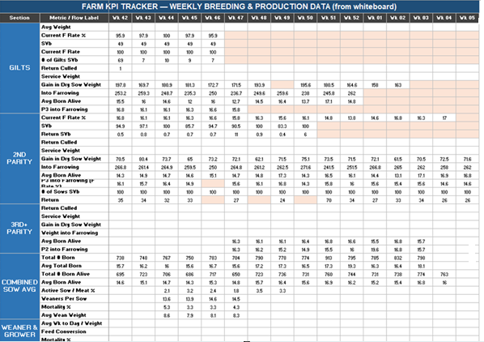

7. Dashboard 2 – Records below mentioned KPI Parameters

- Individual weekly weights for each tagged gilt (8wk to 15wk of age)
- Diet stage fed at each point (W1/W2 starter diets → GR1/GR2 grower diets)
- Actual feed amounts given
- Target vs. actual body weight at set weight milestones
- Target vs. actual daily weight gain, checking if pigs are growing on pace

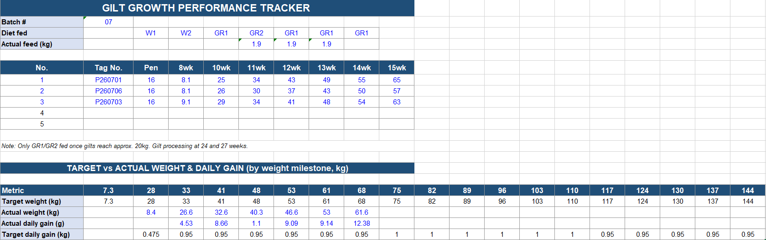

8. Dashboard 3

8.1 WOS (Week of Service) – Gilts service age & weight

- Service age distribution (<13wk, 13-16wk, >16wk) as % of gilts/sows
- Gilt weight bands at service (<230kg, 230-240kg, >240kg)
- Sow suckling (SS) weight range and average

8.2 WOB (Week of Birth) – Farrowing performance, Gilts vs. Total Sows

- Farrowing rate, number farrowed, total born, born alive, born dead, mummified (with per-litter averages)
- Mortality % and weaned/sow

8.3 WOW (Week of Weaning) – broken down by parity

- Same litter metrics (farrowing rate, mummified) compared across 2nd Parity, 3rd Parity, and an "As Gilts" reference column

8.4 Piglet Loss Causes – Active/Post-Active mortality tracker

- A cause-of-death matrix (crushing, starvation, scours, splay legs, etc.) across Active/Post Active/2-4 weeks .

